LAB EXPERIMENT RECORD

SET 25: WEBSITE TRAFFIC ANALYSIS

Department | CSE – AI & DS
Course Code / Course Name | DSA0206 / Data Handling and Visualization
Experiment | Data Visualization using R and Tableau
Name | M V Raghavan
Register Number | 192424373
Date | 15 OCTOBER 2026
Day | Thursday

Aim
To analyze website traffic by visualizing daily page views, identifying the days with the highest click-through rates (CTR), displaying website interactions using a stacked area chart, and outlining an interactive Tableau dashboard.

Dataset: Website Traffic
Date | Page Views | Click-through Rate (%)
2023-01-01 | 1500 | 2.3
2023-01-02 | 1600 | 2.7
2023-01-03 | 1400 | 2.0
2023-01-04 | 1650 | 2.4
2023-01-05 | 1800 | 2.6
Note: The supplied website traffic dataset contains Date, Page Views, and Click-through Rate. The assignment does not provide likes, shares, comments, or traffic-source fields. For Program 3, illustrative interaction values are used only to demonstrate the required stacked area chart; they are not measured values from the supplied dataset.

PROGRAM 1: Line Chart of Daily Page Views
Objective: To visualize the trend in daily page views over the five-day period.
# SET 25: Website Traffic Analysis data <- data.frame(
Date = as.Date(c(
"2023-01-01", "2023-01-02", "2023-01-03",
"2023-01-04", "2023-01-05"
)),
Page_Views = c(1500, 1600, 1400, 1650, 1800),
CTR = c(2.3, 2.7, 2.0, 2.4, 2.6)
)

print(data)

# Line chart of page views plot(
data$Date, data$Page_Views,
type = "o", col = "blue", pch = 19, main = "Daily Website Page Views", xlab = "Date", ylab = "Page Views"
)
grid()

Procedure: Run the code in RStudio. The line chart uses Date on the X-axis and Page Views on the Y-axis. The points show daily values and the connecting line makes changes easier to see.
Observation / Result: Page views increase from 1,500 on January 1 to 1,800 on January 5, with a temporary drop to 1,400 on January 3. The highest value in the supplied sample is 1,800 on January 5.
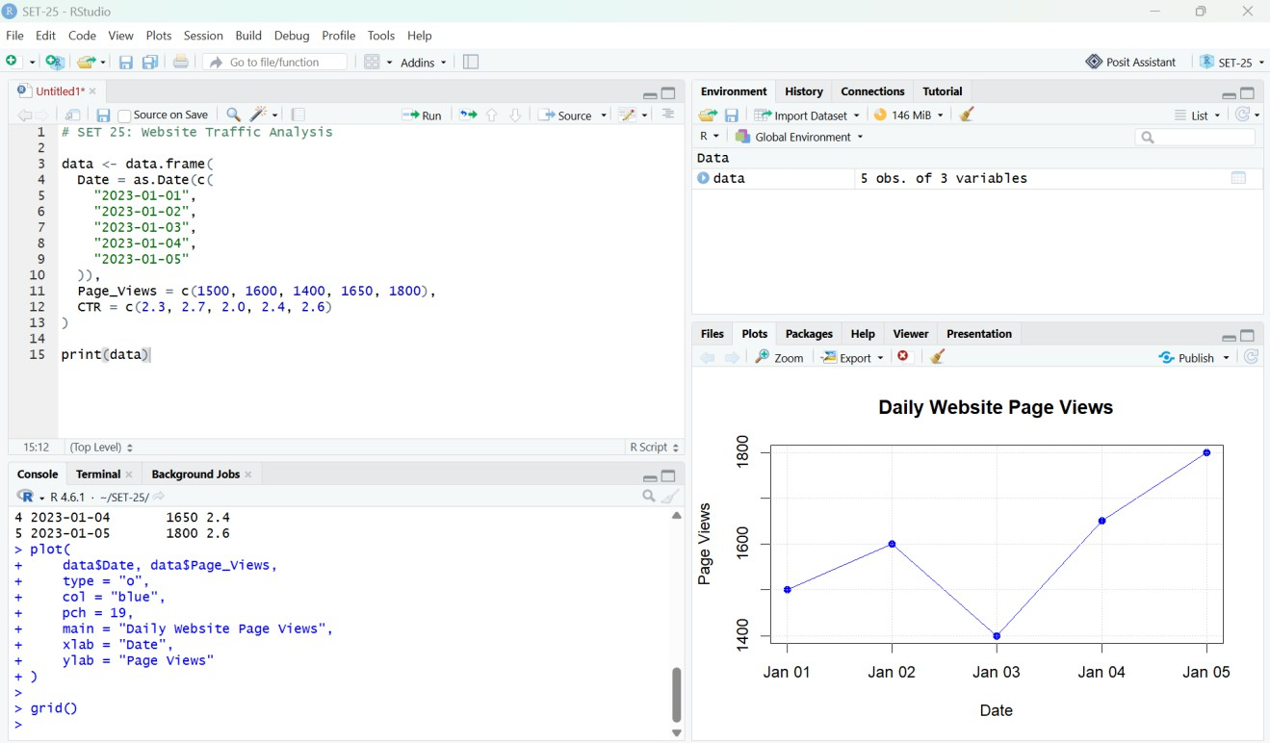
Figure 1. RStudio output: daily website page views.

PROGRAM 2: Bar Chart of Top Three Days by CTR
Objective: To identify the three days with the highest click-through rates.
# Select the top 3 days by click-through rate
top_data <- data[order(data$CTR, decreasing = TRUE), ][1:3, ]

# Bar chart bar_positions <- barplot(
top_data$CTR,
names.arg = format(top_data$Date, "%d-%b"), col = "skyblue",
main = "Top 3 Days by Click-Through Rate", xlab = "Date",
ylab = "Click-Through Rate (%)", ylim = c(0, 3.2)
)

# Add percentage labels text(
bar_positions, top_data$CTR,
labels = paste0(top_data$CTR, "%"), pos = 3
)

Procedure: The data is sorted in descending order of CTR, and the first three records are displayed as a bar chart.

Observation / Result: January 2 has the highest CTR at 2.7%, followed by January 5 at 2.6% and January 4 at 2.4%.
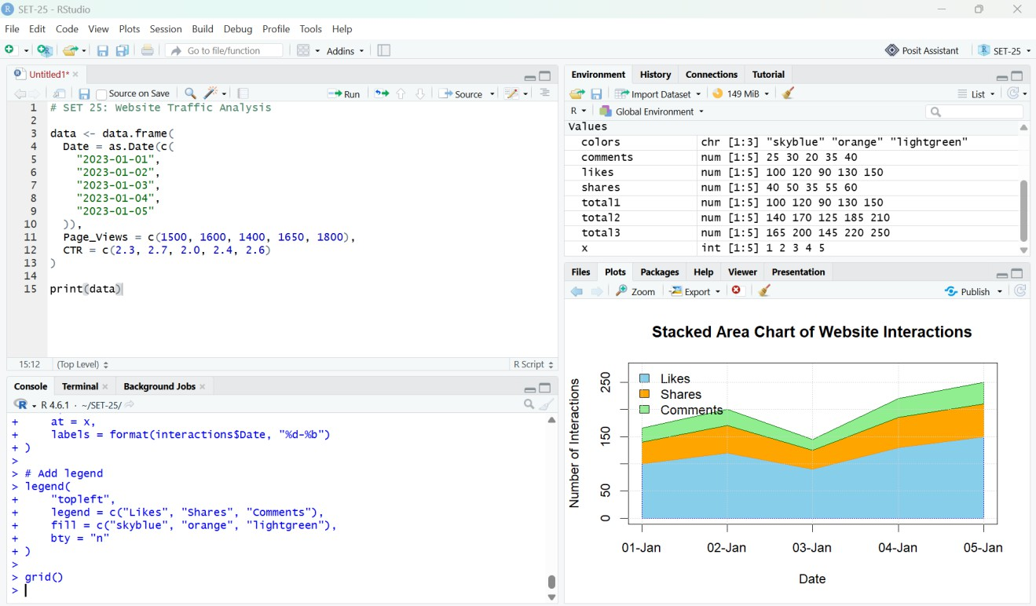
Figure 3. RStudio output: stacked area chart of website interactions.

PROGRAM 3: Stacked Area Chart of Website Interactions
Objective: To demonstrate how likes, shares, and comments vary over time using a stacked area chart. Because interaction counts are not included in the supplied dataset, the values below are illustrative.
# Illustrative interaction data (not supplied measurements) interactions <- data.frame(
Date = as.Date(c(
"2023-01-01", "2023-01-02", "2023-01-03",
"2023-01-04", "2023-01-05"
)),
Likes = c(100, 120, 90, 130, 150),
Shares = c(40, 50, 35, 55, 60),
Comments = c(25, 30, 20, 35, 40)
)

interaction_matrix <- t(as.matrix(
interactions[, c("Likes", "Shares", "Comments")]
))

# Stacked area chart
x <- seq_len(nrow(interactions))
colors <- c("skyblue", "orange", "lightgreen")

matplot(
x, t(interaction_matrix), type = "n",
xaxt = "n", xlab = "Date",
ylab = "Number of Interactions",
main = "Stacked Area Chart of Website Interactions"

)

# Draw stacked areas using cumulative totals likes <- interactions$Likes
shares <- interactions$Shares comments <- interactions$Comments

polygon(
c(x, rev(x)), c(likes, rep(0, length(x))), col = colors[1], border = NA
)
polygon(
c(x, rev(x)),
c(likes + shares, rev(likes)), col = colors[2], border = NA
)
polygon(
c(x, rev(x)),
c(likes + shares + comments, rev(likes + shares)), col = colors[3], border = NA
)

axis(1, at = x, labels = format(interactions$Date, "%d-%b")) legend(
"topleft",
legend = c("Likes", "Shares", "Comments"), fill = colors, bty = "n"
)
grid()

Procedure: The interaction counts are arranged by date. The stacked areas represent likes, shares, and comments, with each upper boundary showing the cumulative total of the categories beneath it.
Observation / Result: In the illustrative values shown, total interactions rise overall across the five dates, with a dip on January 3. These values must not be interpreted as actual website analytics unless replaced with real interaction data.
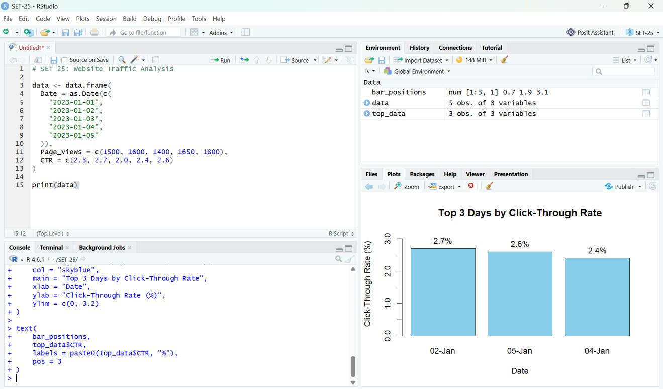

Figure 2. RStudio output: top three days by click-through rate.

PROGRAM 4: Interactive Tableau Dashboard
Objective: To build an interactive dashboard containing a line chart of page views and a bar chart of CTR, along with an interactive map of traffic sources if source-location data is available.

Procedure
- Export the data from R to a CSV file using the code below.
- Open Tableau Desktop or Tableau Public and connect to the exported CSV file.
- Worksheet 1 – Page Views Trend: place Date on Columns and Page_Views on Rows; choose Line in the Marks card.
- Worksheet 2 – CTR by Date: place Date on Columns and CTR on Rows; choose Bar and show CTR labels.
- Create a new dashboard and place both worksheets on it.
- Add a Date filter and apply it to both worksheets. Add a descriptive dashboard title and verify tooltips.
- The assignment also mentions an interactive map of traffic sources and page views by source. The supplied dataset has no traffic-source or geographic fields, so those views require an additional dataset with source and location information.
# Export the website traffic data for Tableau
write.csv(data, "SET25_Website_Traffic.csv", row.names = FALSE)

# Check the folder where the CSV was saved getwd()

Expected result: The Tableau dashboard allows users to compare page-view trends with daily CTR and explore the selected dates through a filter. A traffic-source map can be added after suitable source and location data is supplied.

Overall Result
The website traffic dataset was analyzed using a line chart of daily page views and a bar chart of the top three days by click-through rate. A stacked area chart was demonstrated using explicitly illustrative interaction data. The Tableau procedure combines page-view and CTR charts in an interactive dashboard. In the supplied five-day sample, page views peak at 1,800 on January 5, while CTR peaks at 2.7% on January 2.

Conclusion
R was used to visualize daily traffic and compare click-through rates. The visualizations make it easier to identify high-traffic days and days with stronger click-through performance. Interpretation is limited to the five supplied records; additional data is needed for reliable long-term conclusions, interaction analysis based on actual counts, and a geographic traffic-source map.

